Commitment Form
____Yes, count me in for the Learning Tour Learning Tour March 7-12, 2023! I commit to $2,500 per person for the trip and will make my payment by February 13, 2023.
.
Name(s): | 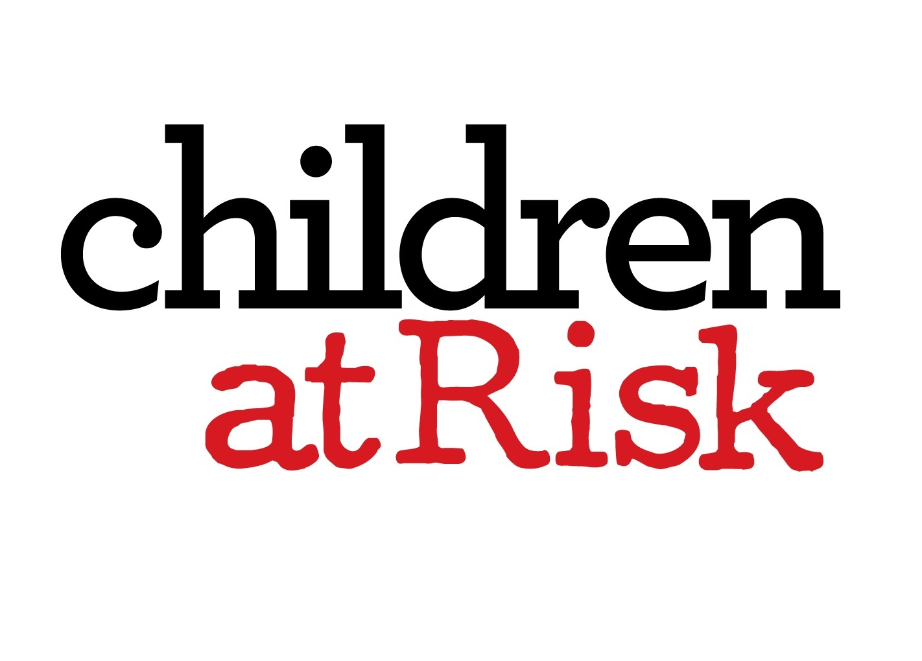
Address:
City, State, Zip:
Email:

Payment Options
Card Number | Please charge my credit card  Please invoice me to the address or email listed.
Exp. Date
CVV
Signature

Event Details
March 7-12, 2023
CHILDREN AT RISK will lead a learning tour of organizations to educate Children at Risk staff and guests on health, education and welfare issues facing children in Cuba and how it applies to children in the U.S.
In the afternoons, we will tour one of the world’s most vibrant cities, Havana (declared a World Heritage Site) and in the evenings, we will dine in Paladares.
The cost is $2,500 per person and covers hotel, ground transportation, most meals plus visits to cultural sites.
Airfare, Cuban tourist card, and personal expenses are not included.
Proceeds and donations will support CHILDREN AT RISK’s continued research and advocacy on behalf of New American Children and children impacted by trafficking and exploitation.

